**The Technological Approaches to Health Care Systems**

**1. INTRODUCTION**

Digital technologies are the use of different electronic devices that store and process health data such as mobile phones, smart watches, internet, computing platforms, and sensors for health care uses. Moreover, the use of electronic information and telecommunication technologies to support long-distance clinical health care, patient health related problems, and public health (Shaffer et al., 2023).

The fast growth in technology has led to an enormous change in the health sector where many digital health devices are commonly used in people’s day to day life for example new devices have been introduced to monitor people’s lives. Furthermore, the use of digital technologies in the health sector increased due to the COVID 19 outbreak.

Digital technologies are increasingly becoming part of the evolution of health care services of systems, support of health processes and steps related to health care. Different technology implementations for example increased use of health applications available on smartphones, artificial intelligence algorithms have increased the use of digital technologies, this was highly boosted by the COVID-19 pandemic (Stuermer & Martin, 2022). The COVID-19 pandemic put a lot of pressure on health and care sector but also accelerated the digital transportation of health and care services.

Different digital technologies have been integrated in the health sector for example sensors, mobile devices and wearables track one’s lifestyle, capture and translate health data. Data of different diseases such as blood pressure, heart rate, stress rate and sugar level are captured using sensor smart devices and is transmitted as electrical pulses for further processing.

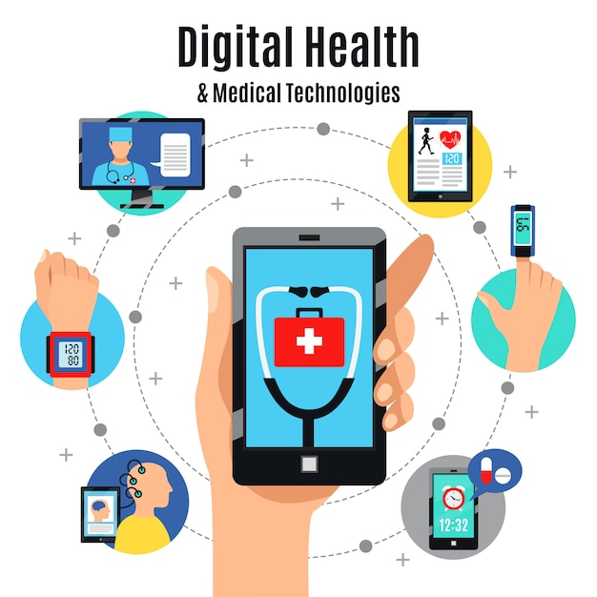

**3. Effects of digital technologies**

In the digital era, digital technology has been effectively implemented in the healthcare sector. These technologies have improved people’s health in different ways. The increased use of digital technologies led to the introduction of various digital devices ways such as enabling real-time monitoring and treatment decision making, they have allowed greater access to health services irrespective of the patient’s geographical location.

Some of the benefits of these devices is they help one to stay on track with their health goals and have a better understanding of their health condition. Patients are self-assured to manage their medical problems. There are automated texts reminders which offer advice from a professional healthcare practitioner. Furthermore, there are different applications which act as a reminder for one to take their medication as prescribed by a doctor. With the help of these devices one can have access to their medical records given the fact that there is a transition where all medical records have been stored electronically. The incorporation of digital technology into one’s life has shown an increase in the awareness of their lifestyle behaviours thus helping in the better understanding of one’s health (Madanian et al., 2023).

Digital technologies are used to collect data which can aid in detecting and diagnosing early stage of diseases such as diabetes, high blood pressure (Ebbert et al., 2023)**.** Health care digital capabilities improve huge quantities of data which are generated which is an opportunity to continuously monitor, analyse and improve quality of healthcare services. Data systems usually contains a wide range of data on a person’s environment, lifestyle and socioeconomic status and well-being as well as the patient’s generated data from wearables and sensors (Sheikh et al., 2021).

Although digital health technologies have played a big role in the health sector there are also a few challenges involved. Several challenges related to the use of digital devices are encountered, these include access to internet connections and people’s unwillingness to adopt virtual care. Adoption to the new digital health care services such video consultations with a doctor is not easy to a certain group of people for example the old people and disabled. This will cause a lot of health inequities which is very important in relation to the acceleration in the use of remote consultations. People with disabilities and older people who in this case might have lower levels of digital literacy are more likely to be excluded from the digital transition. Although the number of adult internet non-users has been declining, the number of adults with disabilities remains high (Sheikh et al., 2021).

Health literacy is one’s ability to understand medical information and terminologies. Patients who may benefit from accessing their medical records are disadvantaged due to their low health literacy which prevents them from understanding their medical results therefore these patients are less likely to use digital technologies available. Furthermore, older adults always prefer their medical results to be presented and explained to them in simple terms which is easier for them to understand (Madanian et al., 2023).

Integrating many types of patient generated data within different devices is challenging because of technology related issues for example poor interoperability and data overload (Sheikh et al., 2021).

**4. Conclusion**

Digital health has changed how healthcare is delivered, experienced by patients, and accessed. The implementation and improvement of health care systems to the digital and advanced systems is such a great opportunity for people mostly in rural areas. This expands the services and technology offered to people.

**5. References**

Ebbert, J. O., Khan, R. G., & Leibovich, B. C. (2023). Health Care Transformations Merging Traditional and Digital Medical Practices. *Mayo Clinic Proceedings: Digital Health*, *1*(2), 63–66. https://doi.org/10.1016/j.mcpdig.2023.02.006

Madanian, S., Nakarada-Kordic, I., Reay, S., & Chetty, T. (2023). Patients’ perspectives on digital health tools. *PEC Innovation*, *2*, 100171. https://doi.org/10.1016/j.pecinn.2023.100171

Shaffer, K. M., Turner, K. L., Siwik, C., Gonzalez, B. D., Upasani, R., Glazer, J. V., Ferguson, R. J., Joshua, C., & Low, C. A. (2023). Digital health and telehealth in cancer care: A scoping review of reviews. *The Lancet Digital Health*, *5*(5), e316–e327. https://doi.org/10.1016/S2589-7500(23)00049-3

Sheikh, A., Anderson, M., Albala, S., Casadei, B., Franklin, B. D., Richards, M., Taylor, D., Tibble, H., & Mossialos, E. (2021). Health information technology and digital innovation for national learning health and care systems. *The Lancet Digital Health*, *3*(6), e383–e396. https://doi.org/10.1016/S2589-7500(21)00005-4

Stuermer, L., & Martin, R. (2022). Characterization of technologies in digital health applied in vision care. *Journal of Optometry*, *15*, S70–S81. https://doi.org/10.1016/j.optom.2022.09.005